Science:

Monday: November 19th-Tueaday: November 20th

Agenda: Part 2: Poster Project on FPSD report

Warm up: none

Instructions: Each person in class has a number for the FPSD report. Find the other person that has the same number as you and create a poster to tell the class about what you learned. You have two days to complete your project.

Math:
Monday: November 19th

Agenda: Know-it notebook 7-7

Warm up: https://youtu.be/-gB1y-PMWfs

Instructions: Complete know it notebook 7-7. Turn to page 371 in the text book. Use the section 7 from chapter 7 to answer fill in the guided notes.

Tuesday: November 20th

Agenda: Hands on lab pg 370

Warm up: Here is a picture of the activity on page 370. Write down the examples shown below to help you remember how to do the activity.
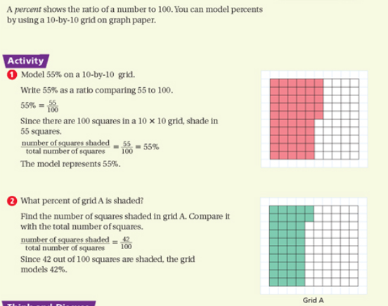

Instructions: Turn to page 370 in the text book. Complete the math activity called Hands on lab. Glue each piece into your journal. Label the activity Hands on Lab 7-7 at the top of your page. When you are done create 3 of your own.

